**Question no 1:**

<html>

<header>

</header>

<body align="left">

    <h2 align="center"><u>Resume</u></h2>

    <p>

        <b>Shreyansh Ranka</b><br>

        Balaji vihar appt;<br>

        Near niramay hospital,<br>

        Ring Road,<br>

        Ichalkaranji-416115,<br>

        Mobile No: 9370044871,<br>

        <b>Email:</b> shrey.ranka300@gmail.com<br>

    </p>

    <hr>

    <p>

        <caption align="left"><b>Educational Qualifications:</b></caption>

        <table cellspacing="15px">

            <tr align="left">

                <th>Qualification</th>

                <th>Institute</th>

                <th>University/Board</th>

                <th>Marks(%)</th>

                <th>Year of passing</th>

            </tr>

            <tr align="left">

                <td>B Tech</td>

                <td>Stanford</td>

                <td>University of California</td>

                <td>89%</td>

                <td>2020</td>

            </tr>

            <tr align="left">

                <td>HSC</td>

                <td>Cambridge</td>

                <td>ICSE</td>

                <td>97%</td>

                <td>2016</td>

            </tr>

            <tr align="left">

                <td>SSC</td>

                <td>Cambridge</td>

                <td>ICSE</td>

                <td>98%</td>

                <td>2014</td>

            </tr>

        </table>

    </p>

    <p>

        <caption align="left"><b>Skills set:</b></caption>

        <table style="font-size: 18;">

            <tr align="left">

                <th>Operating System : </th>

                <td>Windows 9, OS, Linux</td>

            </tr>

            <tr align="left">

                <th>Language : </th>

                <td>C, Cpp, Java</td>

            </tr>

            <tr align="left">

                <th>Front End : </th>

                <td>html, css</td>

            </tr>

            <tr align="left">

                <th>DBMS: </th>

                <td>MySql, oracle</td>

            </tr>

        </table>

    </p>

</body>

</html>

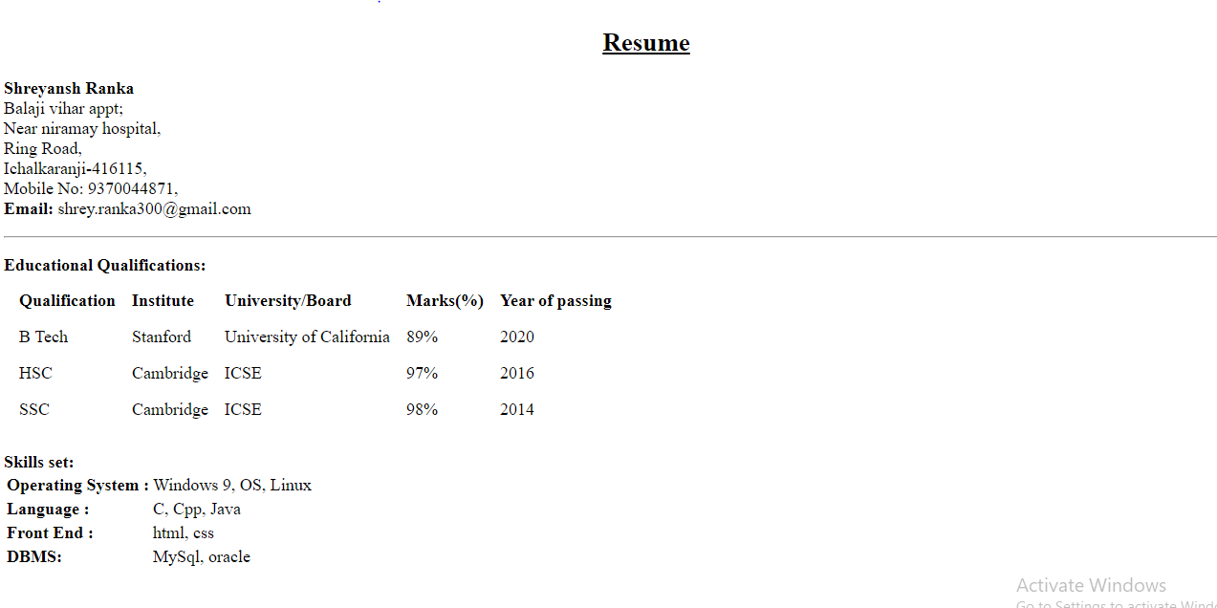

**Question no 2:**

<html>

<header>

</header>

<body>

    <ol type="1">

        <li>Language</li>

        <ol type="i">

            <li>English</li>

            <ol type="A">

                <li>Prose</li>

                <li>Poetry</li>

            </ol>

            <li>Hindi</li>

            <ol type="A">

                <li>Prose</li>

                <li>Poetry</li>

            </ol>

            <li>Marathi</li>

            <ol type="A">

                <li>Prose</li>

                <li>Poetry</li>

            </ol>

        </ol>

        <li>Social Study</li>

        <ol type="i">

            <li>History</li>

            <li>Geography</li>

        </ol>

        <li>Science</li>

            <ol type="i">

                <li>Physics</li>

                <ol type="A">

                    <li>Part1</li>

                    <li>Part2</li>

                </ol>

                <li>Chemistry</li>

                <ol type="A">

                    <li>Organic</li>

                    <li>Inorganic</li>

                </ol>

                <li>Biology</li>

                <ol type="A">

                    <li>Botany</li>

                    <li>Zoology</li>

                </ol>

            </ol>

            <li>Maths</li>

            <ol type="i">

                <li>Algebra</li>

                <li>Geometry</li>

            </ol>

    </ol>

</body>

</html>

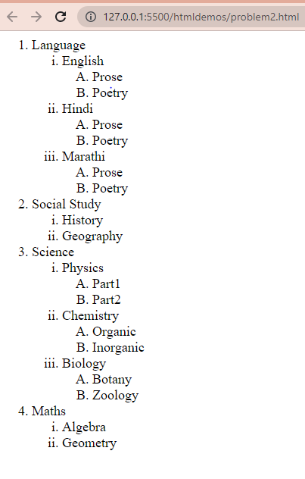

**Question no 3:**

<html>

    <header>

    </header>

    <body link="blue">

        <h2>List of Java books</h2>

        <table border="1px", cellspacing="1px", celpadding="10px">

            <tr>

                <th>Book Title</th>

                <th>Author</th>

                <th>Book price</th>

            </tr>

            <tr>

                <td><a href="">Core java</a></td>

                <td>Cay Horstman</td>

                <td>400</td>

            </tr>

            <tr>

                <td><a href="">Beginning java</a></td>

                <td>Ivar Horton</td>

                <td>600</td>

            </tr>

            <tr>

                <td><a href="">Learning java</a></td>

                <td>Kishori Shahane</td>

                <td>400</td>

            </tr>

            <tr>

                <td><a href="">Java Cookbook</a></td>

                <td>John Kellr</td>

                <td>800</td>

            </tr>

        </table>

    </body>

</html>

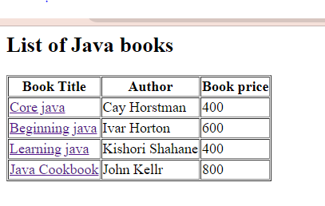

**Question no 3b:**

<!DOCTYPE html>

<html lang="en">

<head>

    <meta charset="UTF-8">

    <meta http-equiv="X-UA-Compatible" content="IE=edge">

    <meta name="viewport" content="width=device-width, initial-scale=1.0">

    <title>Document</title>

</head>

<body>

    <div style="float: left;font-size: 100px;"> <img src="./hcclogo.jpg" height="180" width="530" border="5px"

        style="color:white"></div>

    <table width="100%" border="2px" style="border-collapse: collapse;">

        <tr style="background-color:rgba(17, 189, 189, 0.726); color:white;">

            <td colspan="2">Home Page</td>

            <td colspan="2">Reservations</td>

            <td colspan="2">Facilities</td>

            <td colspan="2">Virtual Tour</td>

            <td colspan="2">Staff</td>

            <td colspan="2">Calendar of Events</td>

            <td colspan="2">Contact Info</td>

            <td colspan="2">Directions</td>

            <td colspan="3">FAQ</td>

        </tr>

        <tr align="right"; style="font-size: 18px; background:white;">

            <td colspan="19">Reservation for Conference Rooms <br>Tuesday,April 11</td>

        </tr>

        <tr style="background-color:rgba(17, 189, 189, 0.726) ;color:white;"align="center">

            <td></td>

        <td colspan="8">Morning</td>

        <td colspan="2">Noon</td>

        <td colspan="8">Afternoon</td>

        </tr>

        <tr style="background-color:rgba(17, 189, 189, 0.726) ;color:white;">

            <td>Room</td>

            <td>8:00</td>

            <td>8:30</td>

            <td>9:00</td>

            <td>9:30</td>

            <td>10:00</td>

            <td>10:30</td>

            <td>11:00</td>

            <td>11:30</td>

            <td>12:00</td>

            <td>12:30</td>

            <td>1:00</td>

            <td>1:30</td>

            <td>2:00</td>

            <td>2:30</td>

            <td>3:00</td>

            <td>3:30</td>

            <td>4:00</td>

            <td>4:30</td>

        </tr>

        <tr rowspan="3" style="background-color: white;">

           <td>Sunrise <br>Room</td>

           <td colspan="4">Marriage Encounter</td>

           <td colspan="4"></td>

           <td colspan="2">Marriage <br>Encounter<br>Luncheon</td>

           <td colspan="4"></td>

           <td colspan="4">Marriage Encounter Talks</td>

        </tr>

        <tr>

           <td>Mountain <br>View Room</td>

           <td colspan="2">Breakfast Club <br>of Ohio</td>

           <td colspan="4"></td>

           <td colspan="4">Ohio Conference of Librarians</td>

           <td colspan="2"></td>

           <td colspan="6">Ohio Book Resale Setup</td>

        </tr>

        <tr>

            <td>Mitchell <br>Theater</td>

            <td colspan="15"></td>

            <td colspan="4"></td>

        </tr>

        <tr>

            <td>Gold room</td>

            <td colspan="2"></td>

            <td colspan="3"> the Tomkins group</td>

            <td colsapn="3">Pearson Planning</td>

            <td colspan="4"></td>

            <td colspan="3">Mothers of Multipliers</td>

            <td colspan="3">Teen connection</td>

        </tr>

        <tr rowspan="2">

            <td>Blue Room </td>

            <td colspan="2"></td>

            <td colspan="3"> Retirement Planning</td>

            <td colspan="3">The senior group</td>

            <td colspan="2">Senior <br>Luncheon</td>

            <td colspan="5">senior classes</td>

            <td colspan="3"> tutoring</td>

        </tr>

        <tr rowspan="2">

            <td>Green <br>Room</td>

            <td colspan="4"> Drivers end </td>

            <td colspan="5">Movie Club</td>

            <td colspan="4"></td>

            <td colspan="3">Tutoring</td>

        </tr>

    </table>

    <table width="100%">

        <tr>

            <td width="50%">

                <p>

                    To reserve a room, please contact Yancy Inwe at

                    extension 388 or e-mail at

                    <a href="yancyinwe@hconfcenter.org">yancyinwe@hconference.org</a> Reservations should be

                    made atleast 48 hours in advance. Cancellations

                    require 24 hours notice. Room deposits will not be

                    returned for cancellations within the 24 hours of the

                    scheduled event.

                </p>

            </td>

            <td width="50%">

                <table style="border: solid rgb(160, 90, 218); border-radius:15px; box-shadow: 20px solid black;">

                </table>

            </td>

        </tr>

    </table>

</body>

</html>

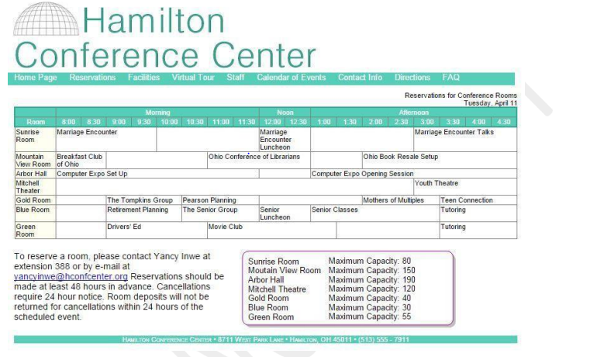

**Question no 4:**

<html>

<head>

</head>

<body border="1px">

    <h2>Indian Airforce Stealth Fighter Jet</h2>

    <p>

        <img src="./AMCA.jpg" width="300" height="200" style="float: left" vspace="8px" hspace="20px"></img>

        The <span style="color:blue"><u>Advanced Medium Combat Aircraft (AMCA)</u></span> is an Indian programme to

        develop a fifth-generation stealth, multirole,

        air superiority fighter for the Indian Air Force and the Indian Navy which will also include sixth-generation

        technologies.[6] The design of the aircraft is carried out by Aeronautical Development Agency (ADA), an aircraft

        design and development agency constituted under Defence Research and Development Organisation (DRDO). It is

        expected to be produced by a public-private joint venture between the DRDO, Hindustan Aeronautics Limited (HAL),

        and an Indian private company.[7] The development cost is estimated to be around ₹15,000 crore (~$2 billion).[8]

    </p>

    <p>

        <img src="./AMCA fly.gif" width="300" height="200" style="float: right" vspace="8px" hspace="20px"></img>

        AMCA will be a single-seat, twin-engine aircraft. The AMCA Mark 1 will come equipped with 5.5 generation

        technologies and Mark 2 will have the incremental 6th generation technology upgrades.[9][10][11] The AMCA which

        is intended to perform a multitude of missions including Air supremacy, Ground-Strike, Suppression of Enemy Air

        Defenses (SEAD) and Electronic Warfare (EW) missions would be a potent replacement for the Sukhoi Su-30MKI air

        superiority fighter, which forms the backbone of the IAF fighter fleet.[9][12] The AMCA design is optimised for

        low radar cross section and supercruise capability.[13][14] Feasibility study on AMCA and the preliminary design

        stage have been completed, and the project entered the detailed design phase in February 2019.[15] A CAD model

        of the aircraft was shown at Aero India 2019. The first flight is expected to be by 2024-25 and serial

        production might begin by 2030.[16][8] The AMCA is currently the only <span style="color:blue"><u>5th generation

                fighter</u></span> under development

        in India, expected to get Ministry of Defence approval in 2022.[17] The aircraft, along with its naval variant,

        is intended to provide the bulk of the manned tactical airpower of the Indian Air Force and the Indian Navy over

        the coming decades.

    </p>

    <p>

        The Project Definition and Preliminary Design phase of AMCA began in 2013.[27] From November 2013 to December

        2014, 9 configurations of AMCA, starting from 3B-01 to 3B-09, were studied using CAD, low speed - high speed

        wind tunnel testing and radar cross section (RCS) testing and eventually by the end of 2014, configuration 3B-09

        was chosen.[28] In 2015, basic design configuration of AMCA was finalized and a detailed AMCA programme report

        was submitted to the IAF, which after review gave concurrence to the programme.[29][30] The AMCA design after

        considerable refinements, has been accepted by IAF in 2016.[31] The Project definition phase was completed by

        2017.[32][33] On 4 April 2018, Indian Defence Minister Nirmala Sitharaman in a written reply to the Lok Sabha

        confirmed that the feasibility study for the AMCA programme has been completed and the programme would be

        completed in two phases viz, technology demonstration phase and full scale engineering development phase.[34]

        The Detailed Design Phase of AMCA has commenced in 2018, as part of the phase, a full-scale model of AMCA will

        be developed for testing stealth features.[15][35] The ADA is expecting to get government approval for the AMCA

        programme by the second quarter of 2021.[36] ₹15,000 crore will be sanctioned for the program soon as per the

        latest reports.[36] The first prototype of AMCA is expected to be rolled out by 2025–26.[8]

        <div align="left" style="float:left">

            <img src="./AMCA2.jpg" width="300" height="200"  vspace="8px" hspace="20px"></img>

        </div>

        The current plan is to procure 7 squadrons of AMCA initially, first two squadrons in Mark 1 configuration,

        equipped with an imported engine and the remaining five squadrons in Mark 2 configuration, equipped with an

        uprated indigenous engine.[37] The Mark 2 of AMCA would also incorporate sixth generation features and

        technologies to stay relevant in the coming decades.[36]

        In 2015, 700 ADA employees were working on the project along with 2,000 employees of DRDO and 1,000 employees of

        HAL supported by over 500 employees of subcontractors of both Indian and foreign firms.

        Work on various technologies was carried out by multiple establishments of DRDO, ADA and HAL which included

        stealth, engine, three-dimensional thrust vectoring, AESA radar, internal weapons bay, serpentine air intakes

        and all other major avionics.[38][39] According to Deputy Air Marshall Sinha "To provide adequate time to Indian

        industries to develop required capabilities, the armed forces will soon come out with a list of technologies of

        interest... underlining that these efforts are expected to synergise indigenous development of advanced

        aerospace systems."[40] In 2015, as part of the Indian MRCA competition, Saab AB made an offer for participating

        in the AMCA programme.[41]

    </p>

</body>

</html>



**Question no 5:**

<html>

    <body>

        <table border="1px" bgcolor="pink">

            <form>

                <tr>

                    <td><label for="nm">Name :&ensp;&ensp;&ensp;</label></td>

                    <td><input type="text" name="name" id="nm" required placeholder="Enter your name"></td>

                </tr>

                <tr>

                    <td><label for="empno">Employee code :&ensp;&ensp;&ensp;</label></td>

                    <td><input type="number" name="Employee code" id="empno" required placeholder="Enter your emp no"></td>

                </tr>

                <tr>

                    <td><label>Department :&ensp;&ensp;&ensp;</label></td>

                    <td><input type="radio" name="department" id="deptno"><label for="deptno">ADMIN</label><br>

                        <input type="radio" name="department" id="deptno"><label for="deptno">HR</label><br>

                        <input type="radio" name="department" id="deptno"><label for="deptno">TECHNICAL</label><br>

                        <input type="radio" name="department" id="deptno"><label for="deptno">ACCOUNTS</label><br>

                    </td>

                </tr>

                <tr>

                    <td>Date : </td>

                    <td><input type="date" name="date" id="date"></td>

                </tr>

                <tr>

                    <td><label for="add">Address :</label></td>

                    <td><textarea rows="4" cols="22" name="address" id="add"></textarea></td>

                </tr>

                <tr>

                    <td><label for="tp">Training Programs Attended :</label></td>

                    <td><input type="checkbox" name="html" id="tp"><label for="tp">HTML/DHTML</label><br>

                        <input type="checkbox" name="html" id="tp"><label for="tp">JAVA</label><br>

                        <input type="checkbox" name="html" id="tp"><label for="tp">.NET</label><br>

                        <input type="checkbox" name="html" id="tp"><label for="tp">C/C++</label><br>

                    </td>

                </tr>

                <tr>

                    <td><label for="trainingp">Training programs need to attend :</label></td>

                    <td><select name="trainingp" id="trainingp">

                        <option value="1">Select one</option>

                        <option value="2">JAVA SCRIPT</option>

                        <option value="3">CORE JAVA</option>

                        <option value="4">MY SQL</option>

                        <option value="5">HTML</option>

                        <option value="6">LINUX</option>

                    </select>

                    </td>

                </tr>

                <tr>

                    <td>Send the information at :</td>

                    <td><span style="color: blue;"><u>empinfo@patni.com</u></span></td>

                </tr>

            </form>

        </table>

    </body>

</html>

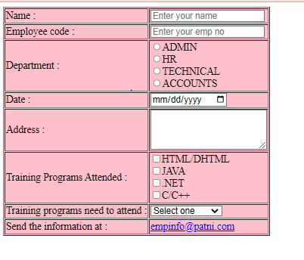

**Question 6:**

<!DOCTYPE html>

<html lang="en">

<head>

    <meta charset="UTF-8">

    <meta http-equiv="X-UA-Compatible" content="IE=edge">

    <meta name="viewport" content="width=device-width, initial-scale=1.0">

    <title>Document</title>

</head>

<body style="border:1px solid blue ;">

    <form>

        <label>

            <h3>Internet Usage Survey</h3>

        </label>

    </form>

    <label> This survey is being conducted to help identify the internet usage pattern of out customers.<br>

        Please take a few moment to complete and subit this short form. Thank you for your cooperation.

    </label>

    <table cellspacing="30px">

        <tr>

            <td>What type of internet connection do you have?<br>

                (Select one)</td>

            <td>

                <select name="iconnection" id="iconnection">

                    <option value="1">Select one</option>

                    <option value="2">Dial-up</option>

                    <option value="3">DSL</option>

                    <option value="4">High Speed Cable</option>

                    <option value="5">Other</option>

                </select>

            </td>

        </tr>

        <tr>

            <td>

                What type of computer do you use most at home?

            </td>

            <td>

                <input type="radio" name="comtype" id="desktop" value="desktop">

                <label for="desktop">Desktop</label>

                <input type="radio" name="comtype" id="laptop" value="laptop">

                <label for="laptop">Laptop</label>

            </td>

        </tr>

        <tr>

            <td>

                How would you describe your main reason for using the Internet?

            </td>

            <td>

                <input type="radio" name="jingalala" id="wra" value="wra">

                <label for="wra">To do work-related activities</label><br>

                <input type="radio" name="jingalala" id="sra" value="sra">

                <label for="sra">To do school-related activities</label><br>

                <input type="radio" name="jingalala" id="fep" value="fep">

                <label for="fep">for entertainment purpose</label><br>

                <input type="radio" name="jingalala" id="other" value="other">

                <label for="other">Other activities</label><br>

            </td>

        </tr>

        <tr>

            <td>

                <fieldset>

                    <legend>Types of site visited</legend>

                    <label>What type of websites do you watch most often <br>Check all that apply</label><br><br>

                    <input type="checkbox" name="jinga" id="si" value="si">

                    <label for="si">Self Improvement</label><br>

                    <input type="checkbox" name="jinga" id="et" value="et">

                    <label for="et">Entertainment</label><br>

                    <input type="checkbox" name="jinga" id="ns" value="ns">

                    <label for="ns">News and Sports</label><br>

                    <input type="checkbox" name="jinga" id="rf" value="rf">

                    <label for="rf">Reference</label><br>

                    <input type="checkbox" name="jinga" id="em" value="em">

                    <label for="em">Email</label><br>

                </fieldset>

            </td>

            <td>

                <fieldset>

                    <legend>Time Spent using internet</legend>

                    <label>During average week,how long do you spend online?</label><br><br>

                    <input type="radio" name="jingala" id="0-3" value="0-3">

                    <label for="0-3">0-3 Hours</label><br>

                    <input type="radio" name="jingala" id="4-6" value="4-6">

                    <label for="4-6">4-6 Hours</label><br>

                    <input type="radio" name="jingala" id="7-10" value="7-10">

                    <label for="7-10">7-10 Hours</label><br>

                    <input type="radio" name="jingala" id="11-14" value="11-14">

                    <label for="11-14">11-14 Hours</label><br>

                    <input type="radio" name="jingala" id="15+" value="15+">

                    <label for="15+">15+ Hours</label><br>

                </fieldset>

            </td>

        </tr>

        <tr>

            <td><label>Please cooment your opinions on Internet privacy and safety</label></td>

        </tr>

        <tr>

            <td colspan="2">

            <textarea name="ta" id="" cols="70" rows="3"></textarea></td>

        </tr>

        <tr>

            <td>

                <label>File Name:</label>

            <input type="text" name="lm" id="lm">

            </td>

            <td>

                <label>Last Name:</label>

                <input type="text" name="km" id="km">

            </td>

        </tr>

        <tr>

            <td>

                <label>Age:</label>

                <input type="text" name="age" id="age" min="18" max="60">

            </td>

            <td>

                <label>Zipcode:</label>

                <input type="text" name="hm" id="hm">

            </td>

        </tr>

        <tr>

            <td><div align="right"><button type="submit" name="bt1" id="bt1">Click to Submit</button></div></td>

            <td><div align="left"><button type="reset" name="bt2" id="bt2">Clear Form</button></div></td>

        </tr>

    </table>

 </body>

</html>

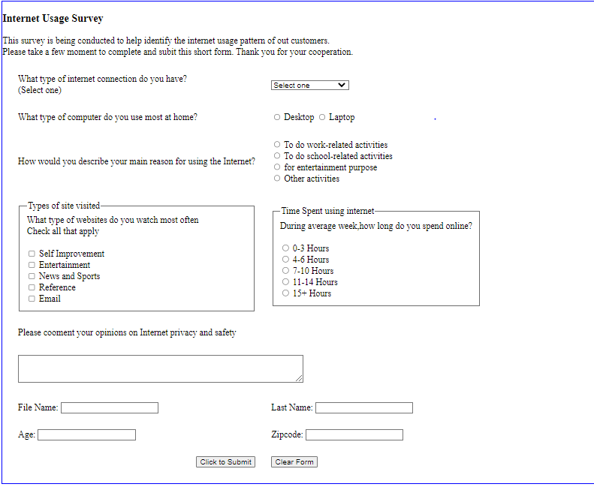

**Question 7:**

<html>

<head>

    <style>

        th {

*font*: bold;

        }

        table,th,td {

*border*: 3px solid grey;

*border-collapse*: collapse;

*width*: 20%;

*height*: 30%;

*align-self*: center;

        }

        #yellow{

*background-color*: yellow;

        }

        .green{

*background-color*: greenyellow;

        }

        .blue{

*background-color*: lightblue;

        }

        table tr:nth-last-child(7){

*align*: left;

*background-color*: pink;

        }

        table tr:nth-child(1){

*font*:bold;

*background-color*: yellow;

*align-content*: center;

        }

    </style>

</head>

<body>

    <table  >

        <tr>

            <th colspan="7">December</th>

        </tr>

        <tr >

            <th>Sun</th>

            <th>Mon</th>

            <th>Tue</th>

            <th>Wed</th>

            <th>Thu</th>

            <th>Fri</th>

            <th>Sat</th>

        </tr>

        <tr>

            <td></td>

            <td></td>

            <td></td>

            <td></td>

            <td></td>

            <td id="yellow">1</td>

            <td class="blue">2</td>

        </tr>

        <tr>

            <td class="green">3</td>

            <td >4</td>

            <td >5</td>

            <td>6</td>

            <td >7</td>

            <td >8</td>

            <td class="blue" >9</td>

        </tr>

        <tr>

            <td class="green">10</td>

            <td>11</td>

            <td>12</td>

            <td>13</td>

            <td>14</td>

            <td>15</td>

            <td class="blue">16</td>

        </tr>

        <tr>

            <td class="green">17</td>

            <td>18</td>

            <td>19</td>

            <td>20</td>

            <td>21</td>

            <td>22</td>

            <td class="blue">23</td>

        </tr>

        <tr>

            <td class="green">24</td>

            <td>25</td>

            <td id="yellow">26</td>

            <td>27</td>

            <td>28</td>

            <td>29</td>

            <td class="blue">30</td>

        </tr>

        <tr>

            <td class="green">31</td>

            <td></td>

            <td></td>

            <td></td>

            <td></td>

            <td></td>

            <td></td>

        </tr>

    </table>

</body>

</html>

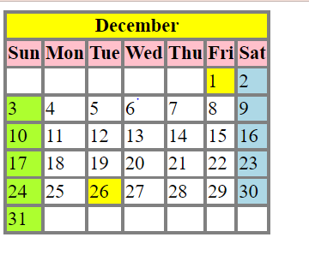

**Question 8:**

<!DOCTYPE html>

<html lang="en">

<head>

    <meta charset="UTF-8">

    <meta http-equiv="X-UA-Compatible" content="IE=edge">

    <meta name="viewport" content="width=device-width, initial-scale=1.0">

    <title>Document</title>

    <style>

        form{

*border*: 2px solid black;

*width*: 50%;

        }

    </style>

</head>

<body>

    <form action="mailto:runeshgazane@gmail.com" method="post" enctype="text/plain">

        <table>

            <tr>

                <td colspan="2">Please fill the Form<br>*required</td>

            </tr>

            <tr>

                <td><label for="problemtypes">Type of Problem</label></td>

                <td><select name="problemtypes" id="problemtypes">

                        <option value="1">Select one</option>

                        <option value="2">Website is down</option>

                        <option value="3">Product is not available</option>

                        <option value="4">Product information missing</option>

                        <option value="5">Online payment not available</option>

                        <option value="6">Other</option>

                    </select>

                </td>

            </tr>

            <tr>

                <td><label>Username</label></td>

                <td><input type="text" required>*</td>

            </tr>

            <tr>

                <td><label>Email</label></td>

                <td><input type="text" required pattern="[A-Za-z0-9].*@.*[.com|.org|.in]$">*</td>

            </tr>

            <tr>

                <td><label>Location</label></td>

                <td><input type="text" required>*</td>

            </tr>

            <tr>

                <td><label>Phone</label></td>

                <td><input type="text" size="10" pattern="[0-9]{10}"></td>

            </tr>

            <tr>

                <td><label>Description of problem</label></td>

                <td><textarea name="dop" id="dop" cols="60" rows="4"></textarea>*</td>

            </tr>

            <tr>

                <td>

                    <label for="notification">Notification of problem solved</label>

                </td>

                <td>

                    <input type="radio" name="notification" id="yes" value="yes">

                    <label for="yes">YES</label>

                    <input type="radio" name="notification" id="no" value="no">

                    <label for="no">NO</label>

                </td>

            </tr>

            <tr style="text-align:center ;">

                <td colspan="2">

                    <button type="submit" name="btn1" id="btn1" value="btn1">Submit</button>

                    <button type="reset" name="btn2" id="btn2" value="btn2">Reset</button>

                </td>

            </tr>

        </table>

    </form>

</body>

</html>

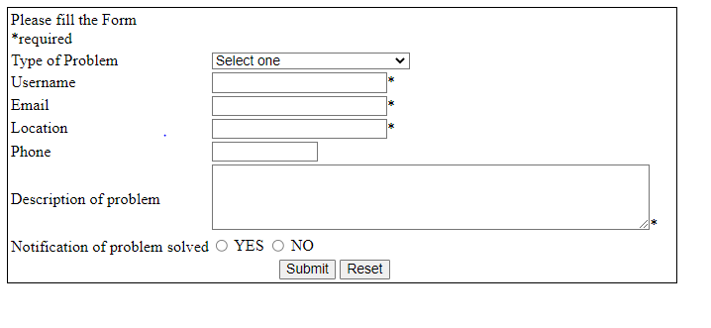

**Question 9:**

<html>

    <body>

        <iframe name="header" src="header.html" height="20%" width="100%" ></iframe>

        <iframe name="Assignments" src="Assignments.html" height="80%" width="20%"></iframe>

        <iframe name="f3" src="" height="80%" width="79%"></iframe>

    </body>

</html>

<html>

    <body>

        <h1 align="center"><b>CDAC HTML Assignments</b></h1>

    </body>

</html>

<html>

    <body>

        <h1>Assignments</h1>

        <p>

            <a href="problem1.html" target="f3"><u>Assignment 1</u></a><br>

            <a href="problem2.html" target="f3"><u>Assignment 2</u></a><br>

            <a href="problem3.html" target="f3"><u>Assignment 3</u></a><br>

            <a href="problem4.html" target="f3"><u>Assignment 4</u></a><br>

            <a href="problem5.html" target="f3"><u>Assignment 5</u></a><br>

            <a href="problem6.html" target="f3"><u>Assignment 6</u></a><br>

            <a href="problem7.html" target="f3"><u>Assignment 7</u></a><br>

        </p>

    </body>

</html>

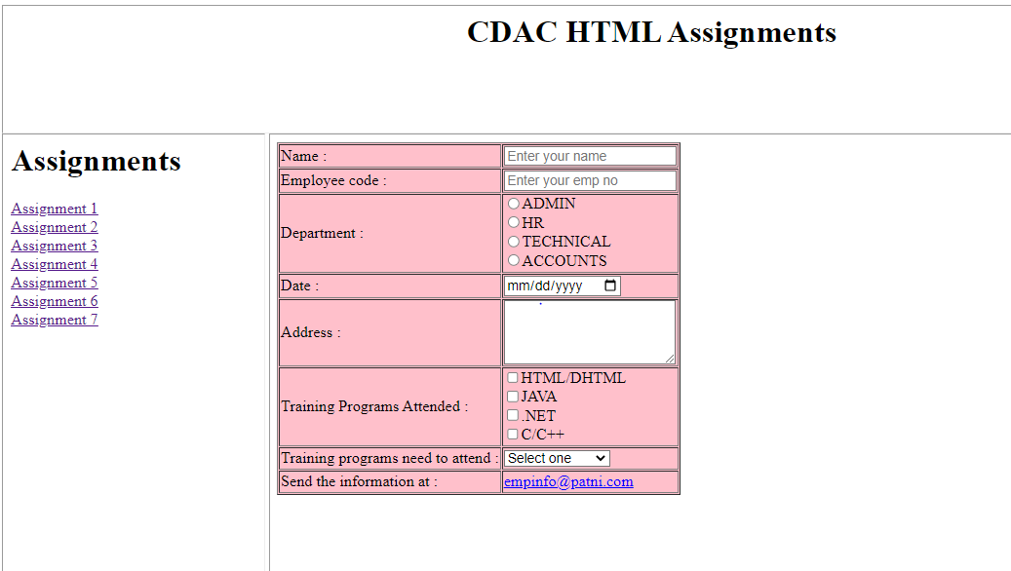

**HTML-5**

**Question 1:**

<!DOCTYPE html>

<html lang="en">

<head>

    <meta charset="UTF-8">

    <meta http-equiv="X-UA-Compatible" content="IE=edge">

    <meta name="viewport" content="width=device-width, initial-scale=1.0">

    <title>Document</title>

   <style>

    .demo{

*border*: 2px solid black;

*width*: 40%;

    }

   </style>

</head>

<body>

    <h1>Appointment Schedular</h1>

    <fieldset class="demo">

        <legend>Personal Information</legend>

        <p>Name <br>

        <input type="text"> <br>

        <p>telephone number <br>

            <input type="text"> <br>

            <p>Email address <br>

                <input type="text"> <br>

                <p>Date of Birth <br>

                    <input type="date"> <br>

    </p>

    </fieldset>

    <fieldset class="demo">

        <legend>Appointment Request</legend>

        <p>What is reason you visited? <br>

            <textarea name="reson" id="reason" cols="30" rows="3" placeholder="">write reason here?</textarea> <br>

            <p>current pain level? <br>

                <input type="range"> <br>

                <p>preffered date <br>

                    <input type="date"><br>

                    <p>preffered time <br>

                        <input type="time"> <br>

        </p>

    </fieldset>

    <button type="submit">submit</button>

</body>

</html>

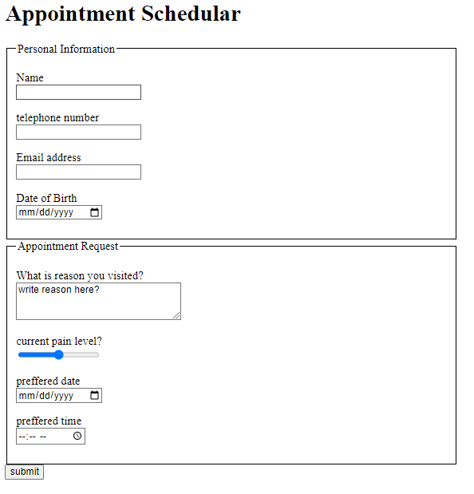

**Question 2:**

<!DOCTYPE html>

<html lang="en">

<head>

    <meta charset="UTF-8">

    <meta http-equiv="X-UA-Compatible" content="IE=edge">

    <meta name="viewport" content="width=device-width, initial-scale=1.0">

    <title>Document</title>

    <style>

        div {

*background-color*: rgb(58, 88, 132);

*color*: aliceblue;

*width*: 550px;

*margin*: 30px;

*padding*: 40px;

        }

        fieldset {

*border-color*: aliceblue;

        }

        .r1 {

*text-align*: right;

        }

    </style>

</head>

<body>

    <div>

        <fieldset>

            <legend align="left">Registration Details</legend>

            <form>

                <table cellpadding="10px" align="center">

                    <tr>

                        <td class="r1"><label for="uni">University:</label></td>

                        <td><input type="text" name="uni" id="uni" required autofocus></td>

                    </tr>

                    <tr>

                        <td class="r1"><label for="inst">Institute:</label></td>

                        <td><input type="text" name="inst" id="inst"></td>

                    </tr>

                    <tr>

                        <td class="r1"><label for="br">Branch:</label></td>

                        <td><select name="branch" id="br" style="width: 100px;">

                                <option value="0">---Select---</option>

                                <option value="Electronics">Electronics</option>

                            </select></td>

                    </tr>

                    <tr>

                        <td class="r1"><label for="br">Degree:</label></td>

                        <td><select name="degree" id="deg" style="width: 80px;">

                                <option value="1">---Select---</option>

                                <option value="BE">BE</option>

                            </select>

                            <input type="radio" name="pursuing" id="pur">Pursuing

                            <input type="radio" name="completed" id="comp">Completed

                        </td>

                    </tr>

                    <tr>

                        <td class="r1"><label for="sem">Average CPI: </label></td>

                        <td><input type="number" name="sem" id="sem" style="width: 40px;">Upto

                            <input type="number" n ame="sem" id="sem" style="width: 40px;">The Semester

                        </td>

                    </tr>

                    <tr>

                        <td class="r1"><label for="exp">Experience: </label></td>

                        <td><input type="number" name="exp" id="exp" style="width: 40px;">Years</td>

                    </tr>

                    <tr>

                        <td class="r1"><label for="web">Your Website or Blog: </label></td>

                        <td><input type="text" name="web" id="web" placeholder="http://" style="width: 150px;"></td>

                    </tr>

                </table>

            </form>

        </fieldset>

    </div>

</body>

</html>

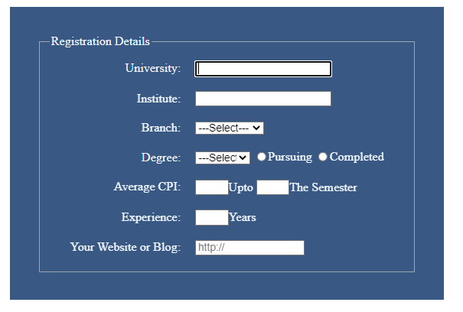

**CSS Question 1:**

<!DOCTYPE html>

<html lang="en">

<head>

    <meta charset="UTF-8">

    <meta http-equiv="X-UA-Compatible" content="IE=edge">

    <meta name="viewport" content="width=device-width, initial-scale=1.0">

    <title>Document</title>

    <style>

        body{

*font-family*: Arial, Helvetica, sans-serif;

*font-size*: small;

*border-collapse*: collapse;

*margin-left*: 25%;

*margin-top*: 10%;

*background*: black;

        }

        .box {

*background-color*: rgba(13, 47, 241, 0.989);

*font-family*: 'Courier New', Courier, monospace;

*color*: aliceblue;

*border*: white;

*border-radius*: 5px;

        }

        #bg {

*background*: black;

        }

        .set {

*border-color*: rgba(13, 47, 241, 0.989);

*border-radius*: 10px;

*width*: 30%;

        }

        .set1 {

*border-color*: rgba(13, 47, 241, 0.989);

*border-radius*: 10px;

*width*: 50%;

        }

        td {

*color*: white;

        }

        input{

*color*: aliceblue;

*background-color*: black;

        }

    </style>

    <script>

*function* myfun() {

*var* x = document.getElementById("my");

            if (x.type === "password") {

                x.type = "text";

            } else {

                x.type = "password";

            }

        }

    </script>

</head>

<body id="bg">

    <fieldset class="set1">

        <legend style="background-color:rgba(13, 47, 241, 0.989); color: aliceblue;">

            Name and address

        </legend>

        <table>

            <tr>

                <td align="right">SSN:&nbsp;</td>

                <td><input type="text" style="background-color: black;border-radius: 5px; "></td>

                <td>

                    <div class="box">FILL N NAME AND ADDRESS</div>

                </td>

            </tr>

            <tr>

                <td align="right">Full name:&nbsp;</td>

                <td><input type="text" style="background-color: black;border-radius: 5px; "></td>

            </tr>

            <tr>

                <td align="right">Street and number:&nbsp;</td>

                <td><input type="text" style="background-color: black;border-radius: 5px; "></td>

            </tr>

            <tr>

                <td align="right">Postal code:&nbsp;</td>

                <td><input type="text" style="background-color: black;border-radius: 5px; "></td>

            </tr>

            <tr>

                <td align="right">City:&nbsp;</td>

                <td><input type="text" style="background-color: black;border-radius: 5px; "></td>

            </tr>

        </table>

    </fieldset>

    <fieldset class="set">

        <legend style="background-color:rgba(13, 47, 241, 0.989); color: aliceblue;">

            Username and password

        </legend>

        <table >

            <tr>

                <td align="right">Username:&nbsp;</td>

                <td><input type="text" style="background-color: black;border-radius: 5px";></td>

            </tr>

            <tr>

                <td align="right">password:&nbsp;</td>

                <td><input type="password" value="pwd" id="my" style="background-color: black;border-radius: 5px";></td>

            </tr>

            <tr>

                <td></td>

                <td><input type="checkbox" onclick="myfun()" >show password</td>

            </tr>

        </table>

    </fieldset>

    <br>

    <button type="submit" style="background-color: rgba(13, 47, 241, 0.989) ; border-color: blueviolet white; border-radius: 5px;" > Register</button>

</body>

</html>

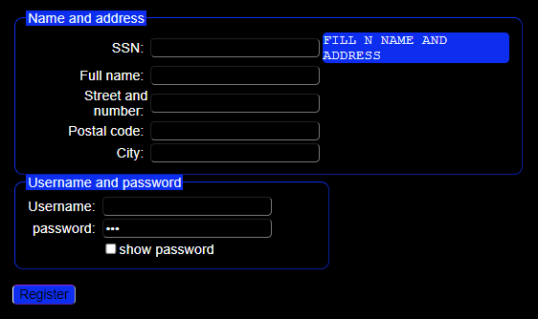

**JavaScript**

**Question 1:**

<html>

    <head>

        <script>

*function* findLargest(){

                a = parseInt(document.getElementById("num1").value);

                b = parseInt(document.getElementById("num2").value);

                c = parseInt(document.getElementById("num3").value);

                if(a>b && a>c){

                    // var largest= a;

                   document.getElementById("largest").innerHTML= a;

                }

                else if(b>c && b>a){

                    // var largest= b;

                    document.getElementById("largest").innerHTML=b;

                }

                else{

                    // var largest= c;

                    document.getElementById("largest").innerHTML=c;

                }

            }

        </script>

        <style>

            body{

*border*: 2px solid blue;

*background-color*: lightpink;

*padding-left*: 30%;

*padding-top*: 15%;

            }

            textarea{

*resize*: none;

            }

        </style>

    </head>

    <body>

        <h2>Find largest number from three.</h2>

        <label for="num1">Number1</label>

        <input type="number" name="num1" id="num1"><br>

        <label for="num1">Number2</label>

        <input type="number" name="num2" id="num2"><br>

        <label for="num1">Number3</label>

        <input type="number" name="num3" id="num3"><br>

        <button type="submit" onclick="findLargest()">See result</button><br>

        <textarea name="lo" id="largest" cols="25" rows="1"></textarea>

    </body>

</html>

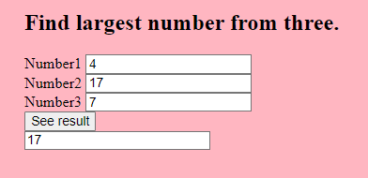

**Question 2:**

<html>

    <head>

        <script>

*function* printmsg(){

*var* a = parseInt(document.getElementById("num").value);

            for(*var* i=1; i<=a; i++){

                document.getElementById("showmsg").innerHTML+=document.getElementById("msg").value+ "<br>";

            }

        }

    </script>

    <style>

        fieldset{

*font-family*: cursive;

*background-color*: lightgrey;

*border*: 2px solid black;

*border-radius*: 1px;

*padding-left*: 30%;

*padding-top*: 15%;

        }

    </style>

    </head>

    <body>

        <fieldset>

        <h2>Print the message as many times the number is.</h2>

        <label for="num1">Number</label>

        <input type="number" name="number" id="num"><br>

        <textarea type="text" cols="25" rows="5" id="msg"></textarea>

        <button type="submit" onclick="printmsg()">See result</button><br>

        <div id="showmsg">

        </fieldset>

        </div>

    </body>

</html>

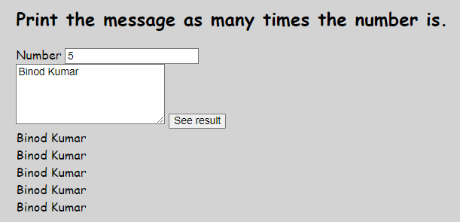

**Question 3:**

<html>

<head>

    <script>

*function* shownumbers() {

*var* num = parseInt(document.getElementById("num").value);

*var* count = 1;

            while (count <= num) {

                document.getElementById("numbers").innerHTML += count + " ";

                count++;

            }

        }

    </script>

    <style>

        body {

*background-color*: blanchedalmond;

*border*: 2px solid saddlebrown;

*font-family*: cursive;

*padding-left*: 30%;

*padding-top*: 15%;

        }

    </style>

</head>

<body>

    <h2>To list all even numbers less than or equal to the number.</h2>

    <label for="num1">Enter a number plz!</label><br>

    <input type="number" name="number" id="num"><br>

    <button type="submit" onclick="shownumbers()">See result</button><br>

    <p id="numbers"></p>

</body>

</html>

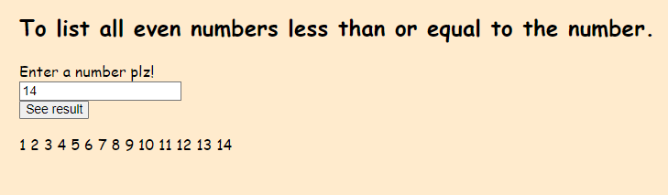

**Question 4:**

<!DOCTYPE html>

<html lang="en">

<head>

    <meta charset="UTF-8">

    <meta http-equiv="X-UA-Compatible" content="IE=edge">

    <meta name="viewport" content="width=device-width, initial-scale=1.0">

    <title>Document</title>

    <style>

        button {

*width*: 30px;

*height*: 30px;

*background-color*: ghostwhite;

        }

        input {

*width*: 70px;

        }

        #demo {

*margin-left*: 40%;

*margin-right*: 45%;

*margin-top*: 5%;

        }

        fieldset {

*background-color*: whitesmoke;

        }

    </style>

    <script>

*function* calculate(*event*) {

            num1 = parseInt(document.getElementById("num1").value);

            num2 = parseInt(document.getElementById("num2").value);

            switch (*event*.target.id) {

                case "btn1":

                    res =  num1+num2

                    break;

                case "btn2":

                    res = num1 - num2

                    break;

                case "btn3":

                    res = num1 * num2

                    break;

                case "btn4":

                    res = num1 / num2

                    break;

            }

            document.getElementById("num1").value = " ";

            document.getElementById("num2").value = " ";

            document.getElementById("res").value = res;

        }

    </script>

</head>

<body >

    <h4></h4>

    <div id="demo">

        <fieldset>

            <label for="num1">Number 1</label>

            <input type="text" name="num1" id="num1" required autofocus><br><br>

            <label for="num2">Number 2</label>

            <input type="text" name="num2" id="num2" required><br><br>

            <button type="button" name="btn1" id="btn1" onclick="calculate(event)">+</button>

            <button type="button" name="btn2" id="btn2" onclick="calculate(event)">-</button>

            <button type="button" name="btn3" id="btn3" onclick="calculate(event)">*</button>

            <button type="button" name="btn4" id="btn4" onclick="calculate(event)">/</button><br><br>

            <label for="res">Result</label>

            <input type=" name="result" id="res" readonly><br>

        </fieldset>

    </div>

</body>

</html>

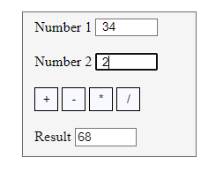

**Question 5:**

<!DOCTYPE html>

<html lang="en">

<head>

    <meta charset="UTF-8">

    <meta http-equiv="X-UA-Compatible" content="IE=edge">

    <meta name="viewport" content="width=device-width, initial-scale=1.0">

    <title>Document</title>

    <style>

        body{

*margin-left*: 30%;

*margin-right*: 40%;

*margin-top*: 10%;

        }

        fieldset{

*background-color*: darkseagreen;

*border*: 6px solid darkgreen;

        }

    </style>

    <script>

*function* showTable(){

*var* num = document.getElementById("num").value;

            str = " ";

            for(*var* i=1; i<=10; i++){

                res = num*i;

                str += num+" * "+i+" = " +res+"<br>";

            }

            document.getElementById("table").innerHTML = str;

            document.getElementById("num").value = " ";

        }

    </script>

</head>

<body>

    <fieldset>

        <label for="num">Enter a Number here</label><br>

        <input type="text" name="num" id="num" ><br><br>

        <button type="button" name="btn" id="btn" onclick="showTable()">Enter</button>

        <div>

            <p id="table"></p>

        </div>

    </fieldset>

</body>

</html>

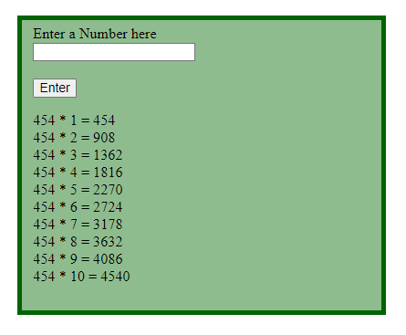

**Question 6:**

<!DOCTYPE html>

<html lang="en">

<head>

    <meta charset="UTF-8">

    <meta http-equiv="X-UA-Compatible" content="IE=edge">

    <meta name="viewport" content="width=device-width, initial-scale=1.0">

    <title>Document</title>

</head>

<style>

    body{

*margin-left*: 30%;

*margin-right*: 40%;

*margin-top*: 10%;

*font-family*: cursive;

*font-size*: small;

        }

    fieldset{

*background-color*: lightyellow;

    }

</style>

<script>

*function* showSum(){

*var* num = parseInt(document.getElementById("num").value);

        sum = 0;

        while(num!==0){

            rem = parseInt(num)%10;

            sum = sum + rem;

            num = parseInt(num) / 10;

        }

        document.getElementById("sum").innerHTML = sum;

        document.getElementById("num").value = " ";

    }

</script>

<body>

    <fieldset>

        <legend align="center">Sum of digits of given five digit number.</legend>

        <label for="num">Enter a Number here</label><br>

        <input type="text" name="num" id="num" ><br><br>

        <button type="button" name="btn" id="btn" onclick="showSum()">Enter</button>

        <div>

            <p id="sum"></p>

        </div>

    </fieldset>

</body>

</html>

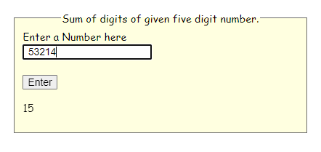

**Question 7:**

<!DOCTYPE html>

<html lang="en">

<head>

    <meta charset="UTF-8">

    <meta http-equiv="X-UA-Compatible" content="IE=edge">

    <meta name="viewport" content="width=device-width, initial-scale=1.0">

    <title>Document</title>

</head>

<style>

    body{

*margin-left*: 30%;

*margin-right*: 40%;

*margin-top*: 10%;

*font-family*: cursive;

*font-size*: small;

        }

    fieldset{

*background-color*: lightyellow;

    }

</style>

<script>

*function* showMin(){

        arr1 = [];

*var* str = document.getElementById("nums").value;

        arr1=str.split(",");

*var* min = arr1[0];

        for(*var* i=1; i<arr1.length;i++){

            if(arr1[i] < min){

                min = arr1[i];

            }

        }

        document.getElementById("min").innerHTML = min;

        document.getElementById("nums").value = "";

    }

</script>

<body>

    <fieldset>

        <label for="nums">Write numbers here seperated by commas</label><br>

        <input type="text" name="nums" id="nums" ><br><br>

        <button type="button" name="btn" id="btn" onclick="showMin()">Enter</button>

        <div>

            <p id="min"></p>

        </div>

    </fieldset>

</body>

</html>

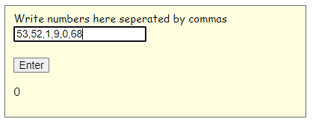

**Question 8:**

<!DOCTYPE html>

<html lang="en">

<head>

    <meta charset="UTF-8">

    <meta http-equiv="X-UA-Compatible" content="IE=edge">

    <meta name="viewport" content="width=device-width, initial-scale=1.0">

    <title>Document</title>

</head>

<style>

    body{

*margin-left*: 30%;

*margin-right*: 40%;

*margin-top*: 10%;

*font-family*: cursive;

*font-size*: small;

        }

        input{

*width*: 40px;

        }

        fieldset{

*background-color*: thistle;

*border*: 5px solid steelblue;

*width*: 350px;

*height*: 150px;

        }

</style>

<script>

*function* showPower(){

*var* num = parseInt(document.getElementById("n").value);

*var* pow = parseInt(document.getElementById("p").value);

        res = 1;

        for(*var* i=1; i<=pow; i++){

            res *= num;

        }

        document.getElementById("power").innerHTML = res;

        document.getElementById("n").value = "";

        document.getElementById("p").value = "";

    }

</script>

<body>

    <fieldset>

        <label for="num">Find power of given number</label><br>

        Number <input type="text" name="n" id="n" >

        Power <input type="text" name="p" id="p" ><br><br>

        <button type="button" name="btn" id="btn" onclick="showPower()">Enter</button>

        <div>

            <p id="power"></p>

        </div>

    </fieldset>

</body>

</html>

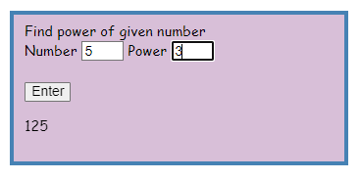

**Question 9:**

<!DOCTYPE html>

<html lang="en">

<head>

    <meta charset="UTF-8">

    <meta http-equiv="X-UA-Compatible" content="IE=edge">

    <meta name="viewport" content="width=device-width, initial-scale=1.0">

    <title>Document</title>

</head>

<script>

*function* calCompundInt(){

*var* p = parseInt(document.getElementById("prin").value);

*var* r = parseFloat(document.getElementById("rate").value);

*var* n = parseInt(document.getElementById("yrs").value);

*var* res = p * Math.pow((1 + r/100),n) - p;

        alert(res);

        showData(res);

    }

*function* showData(*res*){

*var* p = parseInt(document.getElementById("prin").value);

*var* r = parseFloat(document.getElementById("rate").value);

*var* n = parseInt(document.getElementById("yrs").value);

*var* win = window.open("new window");

        win.document.write("<hr><p align='center'>*********Compund Interest********<p><hr>")

        win.document.write("<table><tr><td>Principal<td><td align='right'>"+p+" Rs.</td></tr>")

        win.document.write("<tr><td>Rate of Interest<td><td align='right'>"+r+" %</td></tr>")

        win.document.write("<tr><td>Period of years<td><td align='right'>"+n+" Years</td></tr>")

        win.document.write("<tr><td>Compund Interest<td><td align='right'>"+parseFloat(*res*)+" Rs.</td></tr>")

    }

</script>

<body>

    <fieldset>

        <legend align="center">Find Compound Interest</legend>

        <label for="prin">Principal</label><br>

        <input type="text" name="prin" id="prin" ><br><br>

        <label for="rate">Rate of Interest</label><br>

        <input type="text" name="rate" id="rate" ><br><br>

        <label for="yrs">Period of years</label><br>

        <input type="text" name="yrs" id="yrs" ><br><br>

        <button type="button" name="btn" id="btn" onclick="calCompundInt()">Enter</button>

    </fieldset>

</body>

</html>

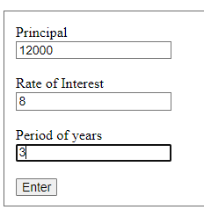

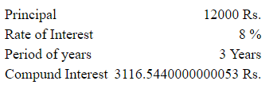

**Question 10:**

<!DOCTYPE html>

<html lang="en">

<head>

    <meta charset="UTF-8">

    <meta http-equiv="X-UA-Compatible" content="IE=edge">

    <meta name="viewport" content="width=device-width, initial-scale=1.0">

    <title>Document</title>

</head>

<style>

    fieldset{

*background-color*: darkblue;

*color*: azure;

*border*: 2px solid azure;

*position*: relative;

*animation-name*: demo;

*animation-duration*: 5s;

*animation-iteration-count*: infinite;

    }

    body{

*margin-left*: 10%;

*margin-right*: 30%;

*margin-top*: 10%;

    }

    @keyframes *demo* {

        0%   {*background-color*:red; *left*: 0px; *top*: 0px;}

        25%  {*background-color*:violet;  *left*: 300px; *top*: 0px;}

        50%  {*background-color*:blue; *left*: 300px; *top*: 300px;}

        75%  {*background-color*:green; *left*: 0px; *top*: 300px;}

        100% {*background-color*:red; *left*: 0px; *top*: 0px;}

    }

</style>

<script>

*function* showDate(){

*var* montharr = ["January","February","March","April","May","June","July","August","September","October","November","December"]

*var* weekarr = ["Sunday","Monday","Tuesday","Wednesday","Thursday","Friday","Saturday"]

*var* dt = new *Date*();

*var* day = dt.getDay();

*var* date = dt.getDate();

*var* month = dt.getMonth();

*var* year = dt.getFullYear();

*var* endDate = new *Date*("2022-12-31");

*var* diff = endDate.getTime() - dt.getTime();

*var* days = parseInt(diff/(1000*3600*24));

        document.getElementById("date").innerHTML=" "+weekarr[day]+", "+date+" "+montharr[month]+" "+year;

        document.getElementById("days").innerHTML= days;

    }

</script>

<body onload="showDate()">

    <fieldset>

        <p id="msg">

            Today is <span id="date"></span>, Welcome, And Good Afternoon to You.<br>

            Number of days left till end of the year: <span id="days"></span>

        </p>

    </fieldset>

</body>

</html>

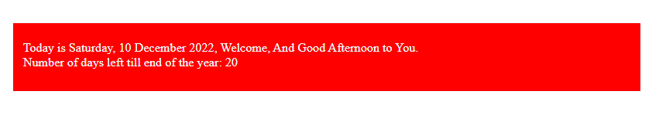

**Question 11:**

<!DOCTYPE html>

<html lang="en">

<head>

    <meta charset="UTF-8">

    <meta http-equiv="X-UA-Compatible" content="IE=edge">

    <meta name="viewport" content="width=device-width, initial-scale=1.0">

    <title>Document</title>

</head>

<style>

    input{

*width*: 80px;

    }

    div{

*margin-right*: 40%;

*margin-top*: 10%;

*margin-left*: 30%;

    }

    fieldset{

*position*: relative;

*animation-name*: demo;

*animation-duration*: 8s;

*animation-iteration-count*: infinite;

    }

    @keyframes *demo* {

        0%   {*background-color*:dimgray;}

        25%  {*background-color*:violet; }

        50%  {*background-color*:rgb(157, 157, 240); }

        75%  {*background-color*:rgb(160, 245, 160); }

        100% {*background-color*:rgb(245, 146, 146);}

    }

</style>

<script>

*function* showDay(){

*var* weekarr = ["Sunday","Monday","Tuesday","Wednesday","Thursday","Friday","Saturday"]

*var* day = parseInt(document.getElementById("day").value);

*var* month = parseInt(document.getElementById("month").value);

*var* year = parseInt(document.getElementById("year").value);

*var* str = year+"-"+month+"-"+day

*var* dt = new *Date*(str)

*var* dd = dt.getDay();

        alert(weekarr[dd])

    }

</script>

<body >

    <div >

        <fieldset id="demo">

            <h3>Enter date to get week day</h3>

            <table>

                <tr>

                    <td><label for="day">Day</label><br></td>

                    <td><label for="month">Month</label></td>

                    <td><label for="year">Year</label></td>

                </tr>

                <tr>

                    <td><input type="text" name="day" id="day"></td>

                    <td><input type="text" name="month" id="month"></td>

                    <td><input type="text" name="year" id="year"></td>

                </tr>

                <tr>

                    <td></td>

                    <td><button type="button" id="btn" onclick="showDay()">Submit</button></td>

                    <td></td>

                </tr>

            </table>

        </fieldset>

    </div>

</body>

</html>

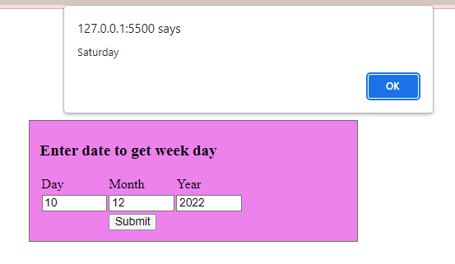

**Question 12:**

<!DOCTYPE html>

<html lang="en">

<head>

    <meta charset="UTF-8">

    <meta http-equiv="X-UA-Compatible" content="IE=edge">

    <meta name="viewport" content="width=device-width, initial-scale=1.0">

    <title>Document</title>

</head>

<style>

    fieldset{

*border*: 2px solid crimson;

*background-color*: chartreuse;

*margin-left*: 20%;

*margin-right*: 40%;

*margin-top*: 10%;

    }

</style>

<script>

*var* arr = [];

*function* addToArray(){

*var* name = document.getElementById("names").value;

        arr.push(name);

        arr.sort();

        document.getElementById("names").value = "";

    }

*function* displayNames(){

            document.getElementById("show").innerHTML += arr + " " ;

    }

</script>

<body>

    <div>

        <fieldset>

            <label for="names">Enter names here...</label>

            <input type="text" id="names"><br>

            <button type="button" id="btn" onclick="addToArray()">Add</button>

            <button type="button" id="btn1" onclick="displayNames()">Display</button>

            <p id="show"></p>

        </fieldset>

    </div>

</body>

</html>

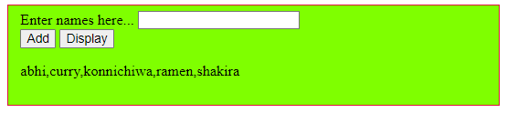

**Question 13:**

<!DOCTYPE html>

<html lang="en">

<head>

    <meta charset="UTF-8">

    <meta http-equiv="X-UA-Compatible" content="IE=edge">

    <meta name="viewport" content="width=device-width, initial-scale=1.0">

    <title>Document</title>

</head>

<style>

    fieldset{

*background-color*: antiquewhite;

*margin-left*: 20%;

*margin-right*: 60%;

*margin-top*: 10%;

    }

    table,td,th{

*border*: 3px solid black;

*border-collapse*: collapse;

*text-align*: center;

    }

</style>

<script>

*var* emparr = [{ id: 1, name: "Shreyansh", sal: 9000 },

    { id: 2, name: "Ajay", sal: 7000 },

    { id: 3, name: "Abhiram", sal: 10000 },

    { id: 4, name: "Shakira", sal: 5000 }]

*function* display(*arr* = emparr) {

        str = "<table><tr><th>Employee id</th><th>Name</th><th>Salary</th></tr>";

        for (*var* ob of emparr) {

            str = str + "<tr><td>" + ob.id + "</td><td>" + ob.name + "</td><td>" + ob.sal + "</td></tr>"

        }

        str = str + "</table>";

        document.getElementById("output").innerHTML = str;

    }

</script>

<body>

    <fieldset>

        <button type="button" id="btn" onclick="display()">Display employee detials</button><br><br>

        <div id="output"></div>

    </fieldset>

</body>

</html>

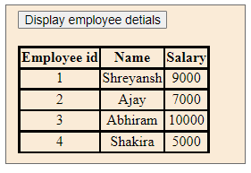

**Question 14:**